Proposal Submission for
Company Name
____________________

< insert Client logo >

Proposal submitted by:

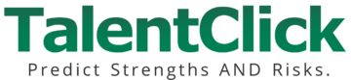

TalentClick Workforce Solutions Inc.
1200-555 Hastings St W
Vancouver, BC, Canada V6B 4N6

Phone: 1-877-723-3778
Email: Info@TalentClick.com

TABLE OF CONTENTS

Part 1: Executive Summary 4
Our Understanding 5
Objectives & Outcomes 5
Our Recommendation 6
Pricing & Costs 8
Expected Gains (Return on Investment) 9
Why Choose TalentClick? 10
Helping You Choose an Assessment Provider 10
Part 2: Detailed Information on the Solution 11
Core Solution: AVP (Attitude-Values-Personality) 11
Workstyle & Performance Profile (WPP) 12
Work Values & Attitude (WVA) 12
Driver Safety Quotient (DSQ) or Safety Quotient (SQ) 12
AVP Combo Reports 13
Additional Assessments 14
Part 3: Setting Up Your Account 15
Pre-Planning 15
Rollout & Training 16
User Training 16
Client Portal 17
Benchmark Library 17
Fit Score Sorter 18
Analytics (Team Reports) 19
Report Configuration (optional) 21
Custom Benchmarking (optional) 21
Competency Mapping (optional) 22
Part 4: How to Assess People and Use the Results 23
What the Results Will Look Like 24
Benchmarking 24
Fit Scores 24
Using the Results 26
Application #1: Use the Results During Pre-Hire Screening 27
Application #2: Use the Results for Interviews and Reference Checks 29
Application #3: Use the Results for Training, Development, Coaching 30
Leadership Coaching & Development 31
Application #4: Succession Planning 32
Helpful Resources 33
TalentClick Customer Stories 35
Part 5: Additional TalentClick Information 36
Summary 36
Accolades 36
Philosophy 37
TalentClick Privacy 37
TalentClick Security 37
Service-Level Guarantees 37
Validity & Reliability of Assessments 38
TalentClick’s Leadership Team 39

Part 1: Executive Summary

Thank you for your interest in TalentClick Workforce Solutions. We are a global leader in the field of psychometrics, with dozens of employee-assessment solutions that can be configured to your needs:

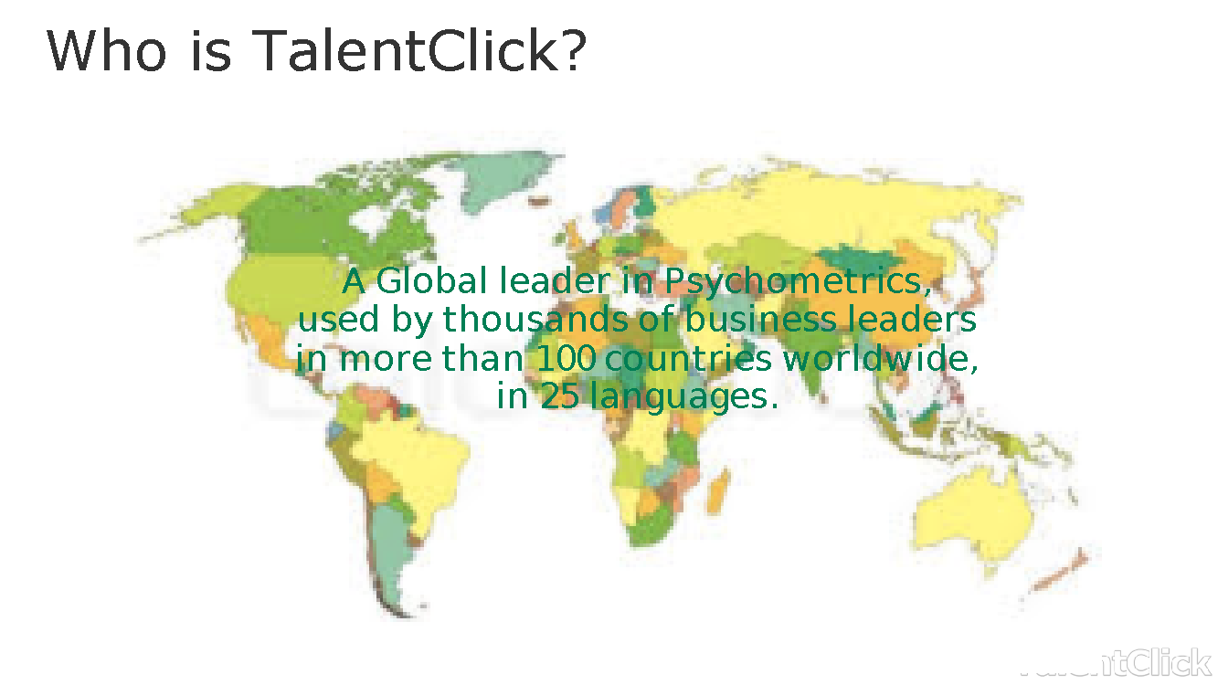

Thousands of business leaders are using our behavioral assessments in more than 100 countries worldwide and in 25+ languages to hire and train better employees.

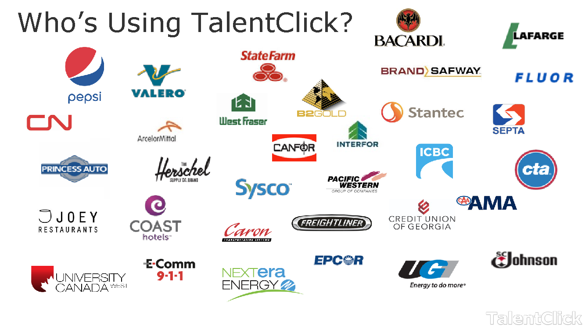

We are delighted about the opportunity to partner with you to help you achieve your goals. This document outlines a proposed solution for your organization.

Our Understanding
Based on our discussion, we understand that your organization is seeking assistance with talent management, specifically in the areas of: (i) pre-hire identification and selection of high performers; and (ii) post-hire employee training, coaching, and development.

Additionally, when it comes to Safety, we understand that your organization has made great strides in the areas of (a) safe equipment, (b) standard operating procedures, and (c) proper safety training, and yet still the company is experiencing negative safety-related outcomes. You have told us that many of your incidents are due to human error and ‘human factors.’ Too often, employees are exhibiting a level of risk tolerance which is unsuitable for a hazardous workplace, and you’d like to be proactive and measure each person’s risk tolerance ahead of time.

Objectives & Outcomes
We realize that we must ultimately help your organization make money, save money, and save time. To that end, will help you achieve the following objectives:

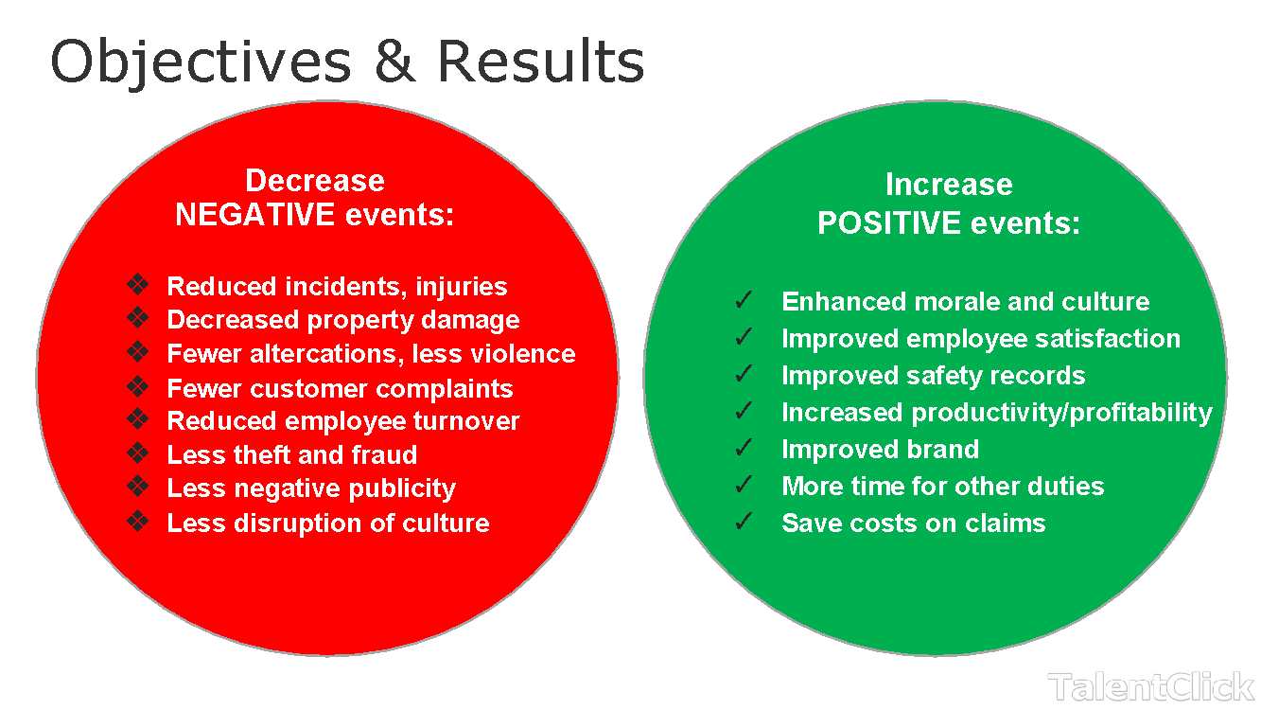

Our Recommendation
Based on our understanding of your business needs and goals, we propose that you utilize the following solution:

- ‘Standard’ level unlimited-use assessment subscription for hiring & training. A ‘Standard’ subscription includes all the products encircled in red below. (The Leadership Profile-LP may be added with a ‘Premium’ subscription).

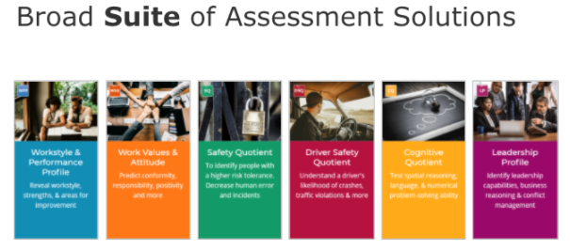

TalentClick will provide you with Employer reports (for use during pre-employment screening and selection) and also Participant reports which may be given to existing employees to help with self-awareness and behavioral change (for use during employee training and development).

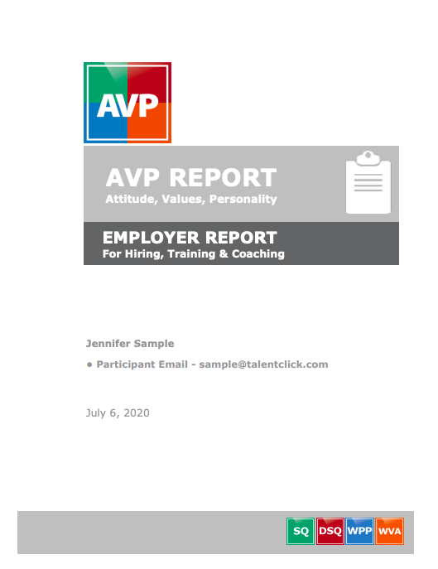 | 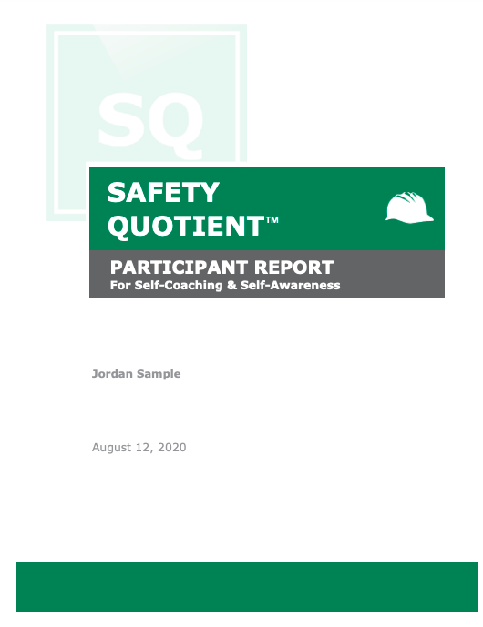

Below are screenshot examples showing the summary page of the Employer reports that you will receive.
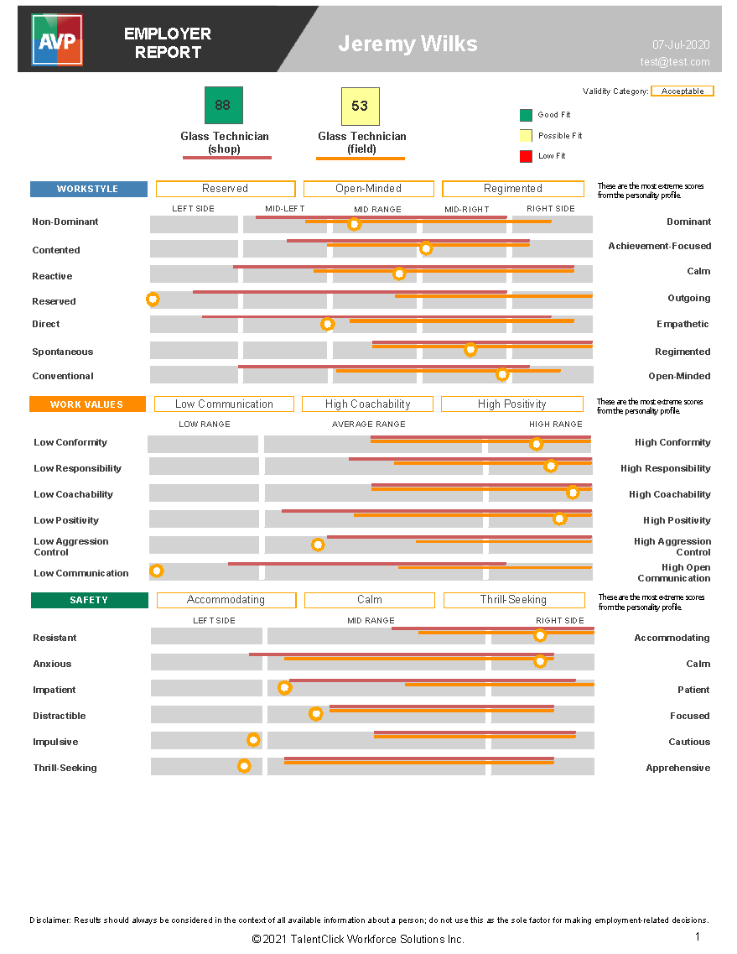

We can also help you assess people for other roles throughout your organization. Here are some common examples:

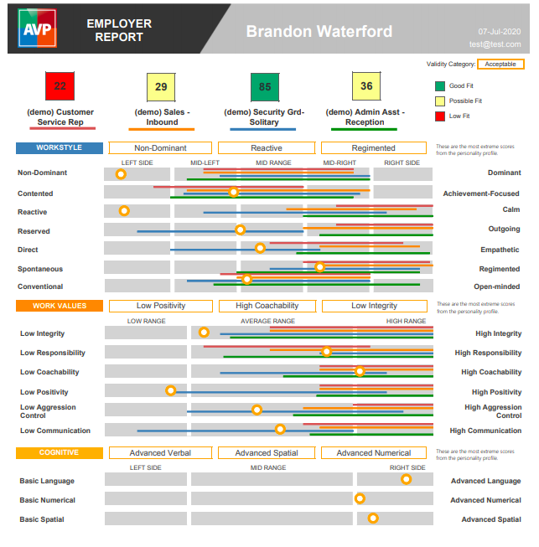 | 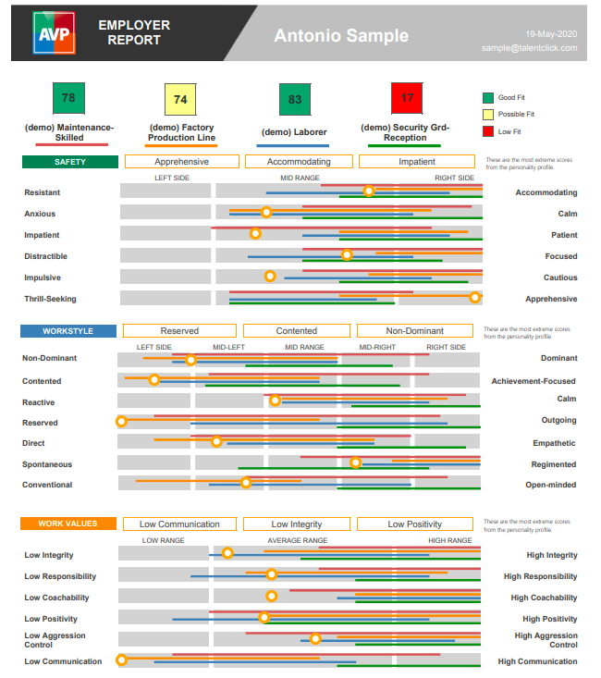

Pricing & Costs
For an organization of your size with a workforce headcount of approximately 500 positions (salaried employees and/or hourly-wage workers) for which you’ll be using our assessments, our pricing options are outlined below:
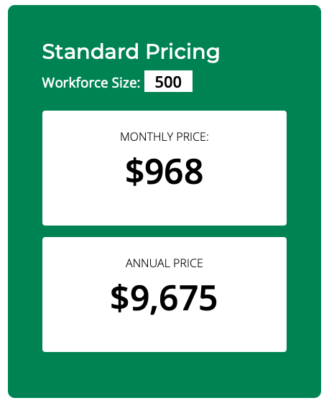
This quote is for a ‘Standard’ subscription, which includes unlimited use of our WPP, WVA, SQ, DSQ, CQ, and EP assessments. With an upgrade to a ‘Premium’ subscription, you can access our popular Leadership Profile (LP) which is a longer and more comprehensive assessment suitable for senior managers and executives.
MONTHLY price means you pay only USD$968 /mo on a month-to-month basis, cancellable at any time (without penalty) with 30 days’ notice.
ANNUAL price means you pre-pay USD$9675 /yr at the start of each year and receive a significant discount. (Your cost works out to be only about $806 per month).
Keep in mind that if you wish to start on a smaller scale, perhaps with one business unit, region, site location, department, or team, we can do that.
At the end of each year, we will review your plan and increase or decrease the pricing depending on your new intended usage or the new size of your organization.
Annual plans renew automatically unless you negotiate otherwise. Fees will be reviewed annually and may increase approx. 0.95% to 5.95%, pegged to the annual inflation rates published by the federal governments of the U.S. and Canada.

Expected Gains (Return on Investment)
After analyzing the information you gave us, we are very confident that we can help you save more than $400,000 per year and achieve a Return on Investment of over 45:1. Add to this the additional gains for improved productivity, increased profitability, and more!
Below is a screen shot of the preliminary ROI analysis we have done for you.
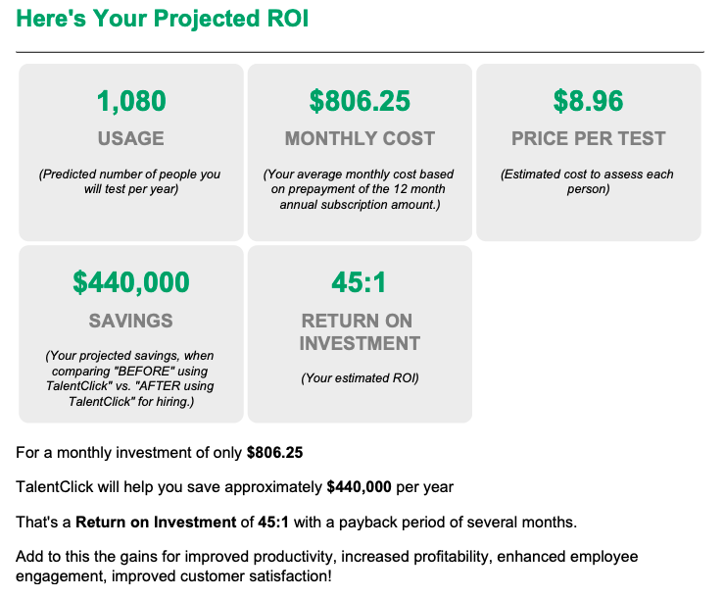
If you would like to complete your own ROI analysis to help you make a business case within your organization, please click here to use our online calculator. (Or copy and paste this address into your web browser: https://www.talentclick.com/roi-calculator/ )

Why Choose TalentClick?
- Unlimited-use subscriptions that are extremely affordable. This lets you assess all applicants before confirmation bias can set in during an interview.
- Easy interpretation of reports in plain language. (No certification required).
- Personalized behavioral interview questions for pre-hire screening
- Personalized performance management tips for post-hire coaching
- Participant reports designed to empower employees with self-insight and self-coaching
- Self-serve Benchmark Library with 100’s of job titles for creating ideal hiring profiles
- Team analytics for organizational business intelligence and decision support
- Customizable reports with your own organization values and language
- Multi-layered content focused on strengths AND risks for all levels of employees.
- Cloud-based system, available 24/7
- No software to install. No complicated setup.
- Normative testing (vs. Ipsative) so you’re using a validated, legally defensible tool (rather than an Ipsative testing tool) for selection.

Helping You Choose an Assessment Provider
Selecting an assessment vendor can be difficult. We know; we have learned from hundreds of clients about their needs and challenges when going through this process. That’s why we have put together a guide and checklist that many employers find helpful. We have tried to make it as non-partisan as possible, and we hope you find it useful. To view or download our ‘Guide to Selecting an Assessment Vendor’, click here: https://www.talentclick.com/wp-content/uploads/2020/02/how-to-select-a-vendor-ebook.pdf

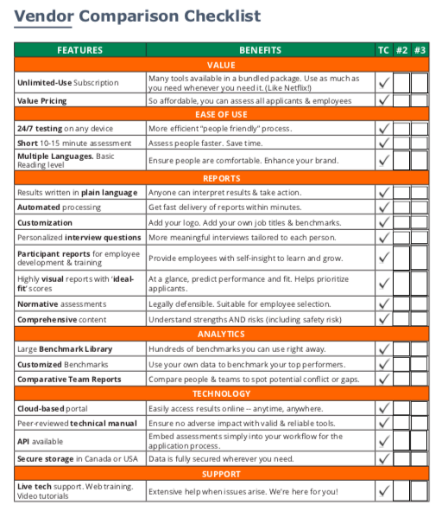

Part 2: Detailed Information on the Solution

Core Solution: AVP (Attitude-Values-Personality)
(https://www.talentclick.com/solutions/core-bundle-avp/).
We have bundled our 3 most popular assessments into one easy-to-use tool, providing employers deep pre-hire and coaching insights within minutes.
The AVP solution helps to identify the personality traits and “default settings” which are correlated with successful workplace performance. We have a unique focus on Behavioral Risk, predicting the likelihood of people’s inherent “hard wiring” for positive attitude, conformity, achievement-orientation, responsibility, communication, coachability, aggression, distractibility, and more.

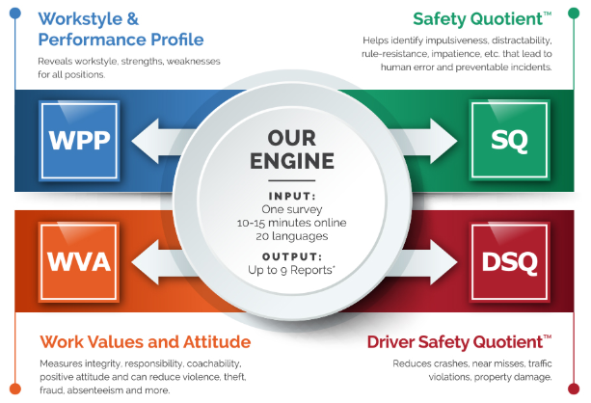

As you can see from the image above, the AVP includes the following assessments, which can all be generated from the one 10-15 minute survey-questionnaire:

Workstyle & Performance Profile (WPP)  The WPP—which is based on the traditional Five Factor Model of Personality—gives a preview of an individual’s natural “default” workstyle and provides accurate expectations for performance. The WPP reports contain action-oriented feedback on how to leverage the candidate’s natural workstyle and strengths. The reports also outline possible areas for coaching/development, job fit considerations, management tips, and suggested interview and reference-checking questions.  *Employer and Participant versions both  (https://www.talentclick.com/solutions/hiring-assessment-tool/) | 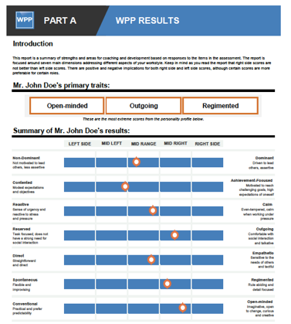
Work Values & Attitude (WVA)  The Work Values & Attitude (WVA) assessment is designed for employers to use at the screening, evaluation, and selection stage of the hiring process. When used as a part of a comprehensive selection process, the WVA will provide greater insight into an applicant’s conformity, sense of responsibility, coachability, positive or negative attitude, aggression control, and openness to communication.  *Employer version only  (https://www.talentclick.com/solutions/work-values-attitude/) | 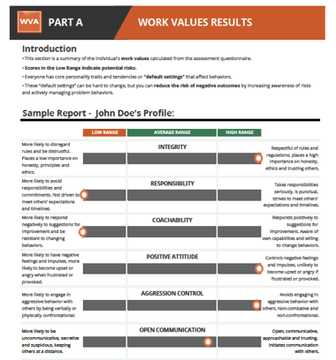
Driver Safety Quotient (DSQ) or Safety Quotient (SQ)  The SQ and DSQ are for organizations concerned with safety to use either (i) during the hiring stage or (ii) for existing employees to teach ‘Safety Self-Awareness’ as part of a learning and development program. This report predicts the likelihood of someone acting impulsive, distractible, rule resistant, impatient, and more, and can be used to reduce safety incidents, road crashes, injuries, fatalities, property damage, and work stoppages / downtime. Employers use either the SQ or DSQ report on an individual but generally not both.  *Employer and Participant versions both  (https://www.talentclick.com/solutions/safety-quotient/)  (https://www.talentclick.com/solutions/driver-safety-assessment/) | 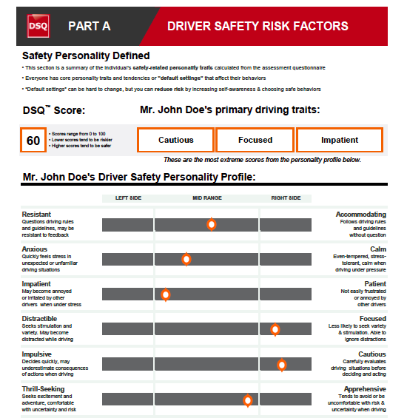

AVP Combo Reports

Your unlimited-use subscription will include our AVP (Attitude-Values-Personality) flagship assessment. The summary page of each assessment report displays “ideal scoring ranges” based on extensive benchmarking of high performers in each role. We have hundreds of roles in our Benchmark Library that you can use right away.

To make it extremely easy for your recruiters and hiring managers to prioritize job applicants, the reports will have “ideal fit” scoring ranges based on benchmarking of top performers per job type. See the sample combo reports below:

Note: The benchmarked “ideal fit” scores can be created for any job title in any industry.

Additional Assessments

Our Standard subscription includes our Cognitive Quotient (CQ), and English Proficiency (EP) assessments.

Cognitive Quotient (CQ)  25-30 minute assessment for junior and intermediate levels. CQ measures basic problem solving and spatial abilities, along with data entry skills and typing speed.  (https://www.talentclick.com/solutions/cognitive-quotient/) | 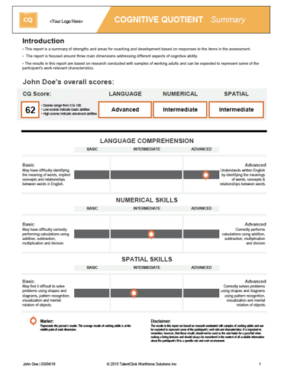
English Proficiency (EP)  20-25 minute assessment that measures ability to comprehend basic English language instructions, procedures, signage, etc.  (https://www.talentclick.com/solutions/english-proficiency-assessment/) | 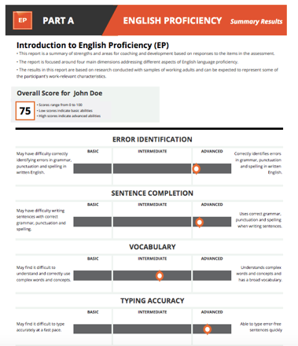

As part of a Premium level annual subscription, we also include our Leadership Profile (LP).

Leadership Profile (LP)  45-60 min online assessment for senior managers and executives, measuring leadership tendencies, business reasoning abilities, and conflict resolution style.  Note: If you wish to use only one or two of the three sections, we can break out the desired sections separately.  (https://www.talentclick.com/solutions/leadership-profile/) | 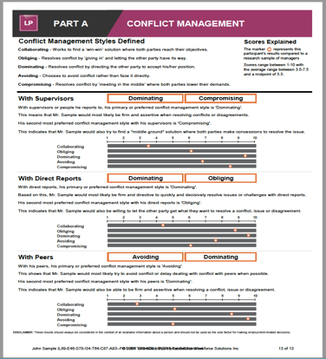

Part 3: Setting Up Your Account

Pre-Planning
Once the contract is signed, account setup typically takes between 3 days to 3 weeks, depending on availability of your team for calls and online meetings. This setup includes configuration of your testing links and training of your administrators.
When we start working with you, we ask that you designate one or more key contacts for us. TalentClick will maintain contact with this group via email, online meetings, and phone calls (and in-person meetings if required).
You will need to decide on answers to these account setup questions:
- Which of the reports would you like to receive?
- Who should have access to the results in your cloud-based portal account?
- Do you also want reports emailed to you as PDF attachments? If so, to whom do you want the results sent? (The reports can be sent to as many people as you wish.)
- Do you want Participants to automatically receive their own reports? We recommend No, unless you are sending it to employees only (not applicants) and you have already communicated the purpose of the tool and how to use it.
- Would you like your logo on the survey landing page and/or on the reports?

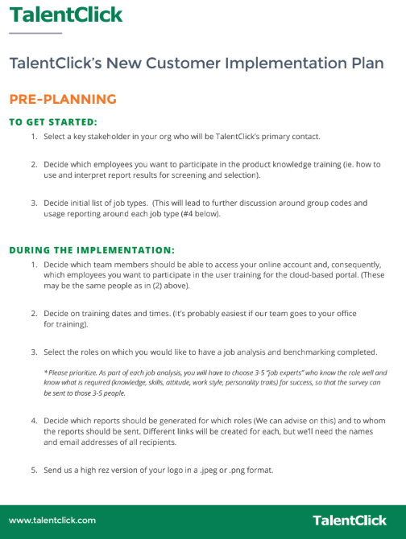

Rollout & Training

The TalentClick project manager assigned to your account will provide regular updates to your key contact(s), including key deliverables, timelines, and next steps. Your key contact will sign off on deliverables throughout the project.
Sessions for employee development, executive coaching and employee coaching will be scheduled at regular intervals during the contract term, based on your requirements and timelines.
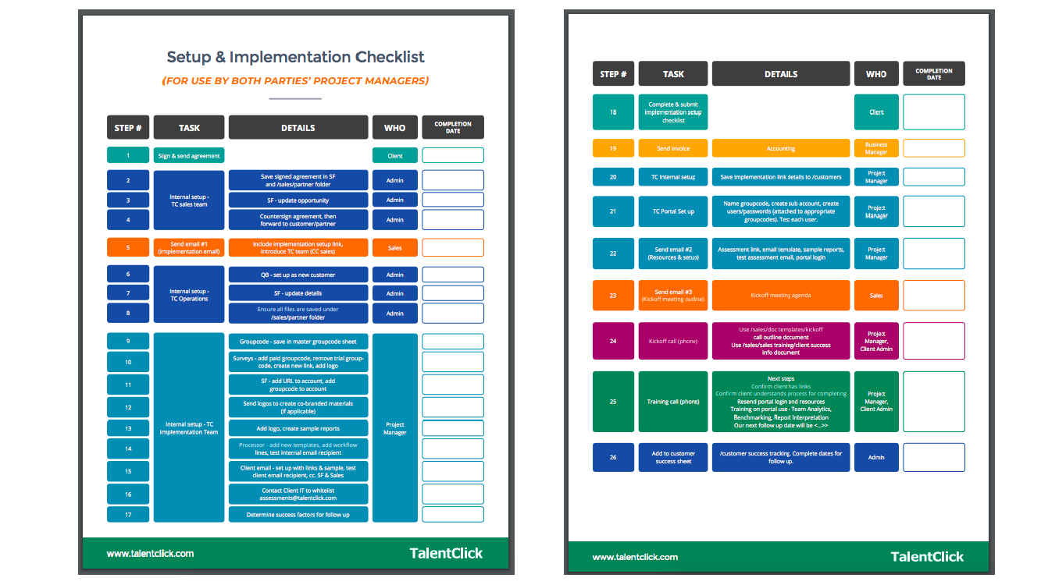

User Training
User training is provided in 2 sessions:
- Product Knowledge Training: Meant for recruiters and hiring managers. Focuses on the soft skills needed for interpreting the reports and using the information for pre-screening, interviews, performance management and coaching of a new hire. This session generally takes around 1 hour and is conducted remotely via a web session. You can have as many users attend this as you wish. Each initial session is included at no charge, and subsequent sessions may be purchased at our standard hourly consulting rate.
- Technical Training: Meant for any admin users of our cloud-based portal who wish to use our system for inviting applicants, retrieving reports, running utilization reports, creating team analytics reports, modifying benchmarks, and more. This session generally takes around 1 hour and is conducted remotely via a web session. You can have as many users attend this as you wish. Each initial session is included at no charge, and subsequent sessions may be purchased at our standard hourly consulting rate.

Client Portal
The TalentClick portal is available 24/7 for access to reports, results, benchmarking, fit scores and team analytics. A secure login is provided to each client. Assessment results are automatically saved to the portal and may be viewed or downloaded. Search criteria include report type, date and product.
The self-serve portal also features team analytics and benchmarking to provide insights into where an applicant (or team) may excel, and where there could be potential gaps.
For an overview of our portal, please click here: http://videos.talentclick.com/watch/PyaYBR57qhZU1aWqNQaZAb?
Below are screenshots showing examples of portal functionality:
Report Builder: interactive, easy to configure different reports
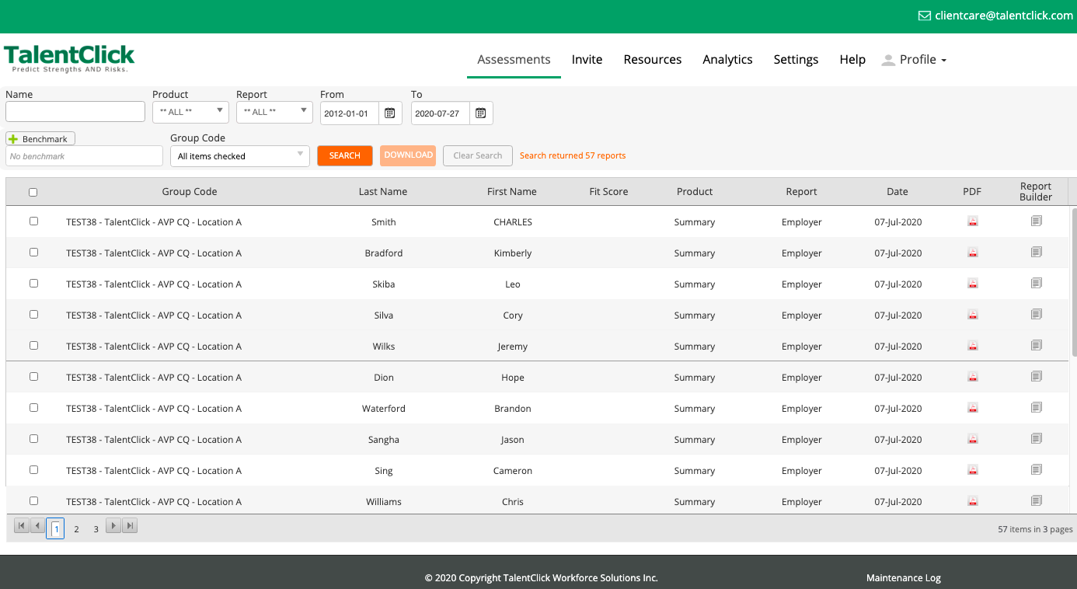

Benchmark Library
(hundreds of job titles to choose from)
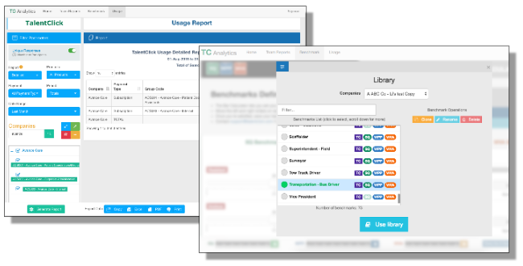

Fit Score Sorter
(Save time by ranking many applicants at one time)
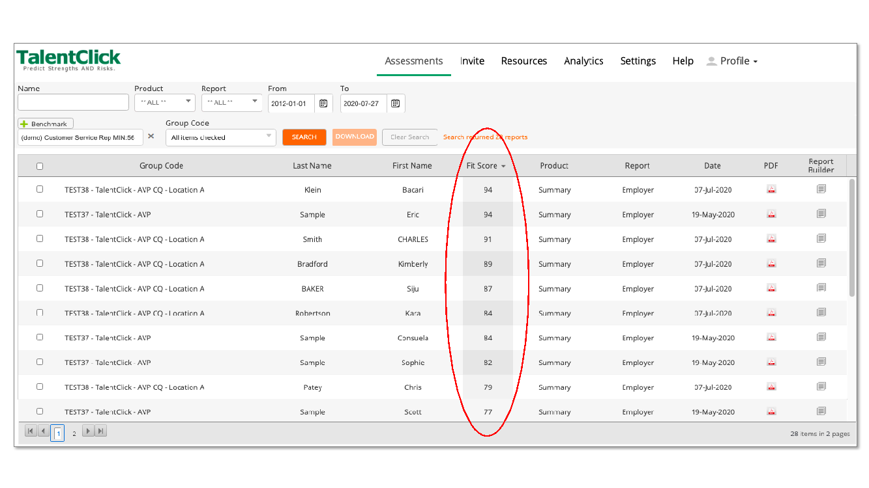

Analytics (Team Reports)
Using our portal system, you can create scatterplot graphs showing groups of people in various locations, departments, teams, job types, and so on. You can spot behavioral patterns and trends, predict risks and leverage strengths by turning information into actionable business insights. The easy-to-use function helps achieve the following:
- Improve team communication, problem solving and performance by using group reports to facilitate fast and effective team building.
- Bring teammates together to better understand each other’s workstyles and personalities. It is the most effective way to improve how your team functions and interacts with each other.
- Develop team and individual action plans to help improve performance and minimize conflict.
- Identify patterns of personality fit to job type, leadership potential, optimum performance.
- Collaborate positively and effectively to strengthen culture and reach company goals.

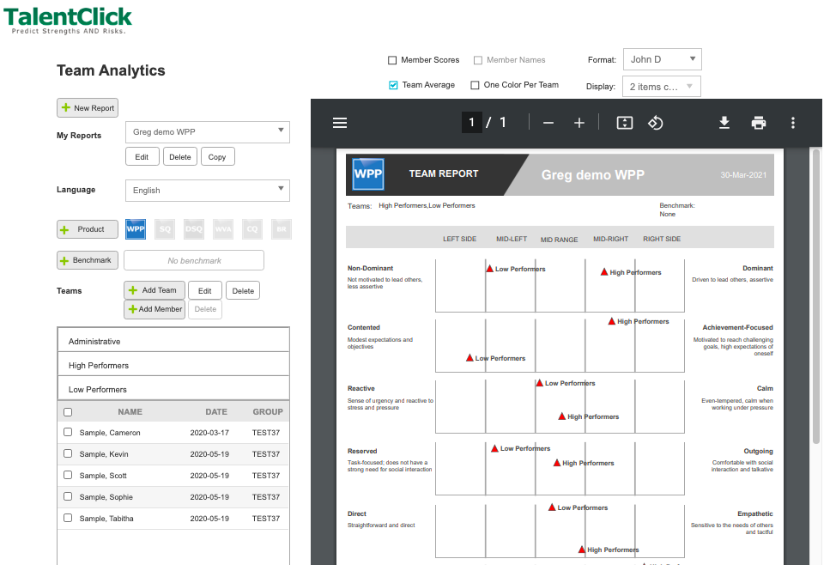
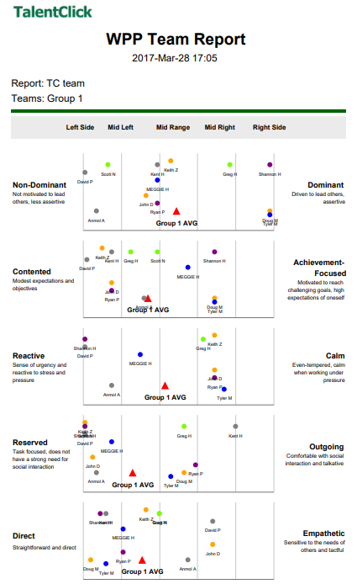

Report Configuration (optional)

Upon your request, TalentClick can co-brand—with your logo and color scheme—the online assessment invitation, landing page, survey, and assessment reports.

Custom Benchmarking (optional)

If you wish to pay extra, rather than using our off-the-shelf benchmark library, TalentClick can create customized benchmarks and “ideal fit” scores to predict the strengths and personality traits needed to be a top performer in specific roles in your particular organization. This is done by benchmarking your top performers and then mapping their aggregate scores to view the common patterns. Once your custom benchmarks have been developed, your organization can use them to compare with profiles of new candidates for a role and hire to match (or complement) a top performing profile. Or, for current employees, benchmarks bring insights for employee development, coaching and self-awareness.

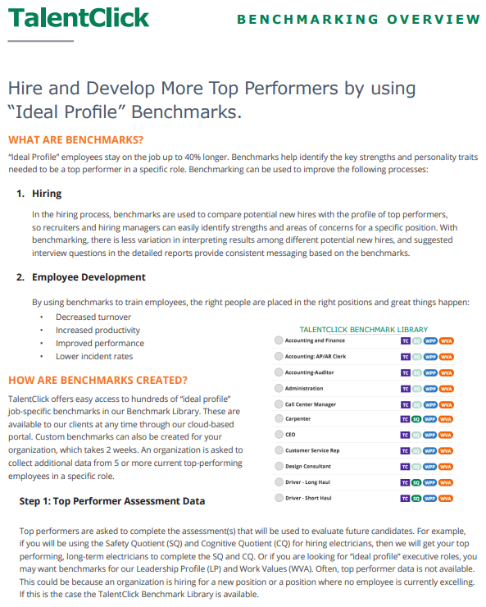

Competency Mapping (optional)
If you wish, when starting the engagement with your organization, TalentClick can initiate a Competency Mapping process to ensure your unique role competencies are more accurately represented in the benchmarks. (Note: This is optional. You can start using the “off the shelf” benchmarks in our library right away.) We have worked with many organizations - including the Insurance Corporation of British Columbia (ICBC) and others - on mapping their job competencies to our assessment results in order to create a more powerful predictor of success and a clear “line of sight” to fit with the organization. The following image is a high-level example:
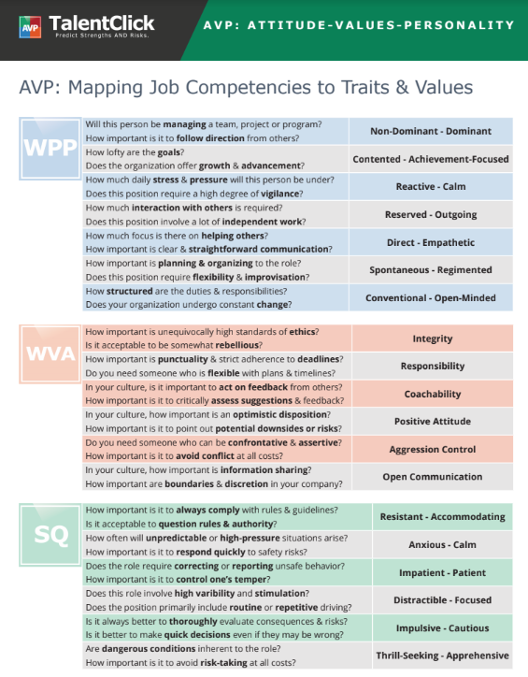

Part 4: How to Assess People and Use the Results

You can invite participants (employees and applicants) to complete the assessments using our online portal or by emailing a link directly to each person. You can also embed a link on your Careers page or online job advertisements.
The participant can complete the assessment survey questions on any Internet-enabled device, including a computer or mobile phone. The AVP assessment takes 10-15 minutes and is available in more than 25 languages, including French, Spanish, Portuguese, Italian, German, Dutch, Polish, Russian, Ukrainian, Hindi, Tagalog/Filipino, Japanese, Korean, Chinese, Arabic, and more.
After a participant has completed the assessment, our system will automatically process the results and deliver the reports within 1 hour (and often within minutes).
Reports will be automatically stored in your cloud-based account in our portal. Additionally, we can adjust the settings so that reports are emailed to you as PDF attachments.

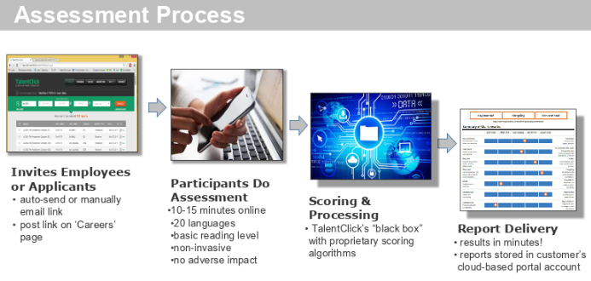

What the Results Will Look Like
The reports are short, highly visual, and easy to read. The results are written in plain language and are easy to interpret.
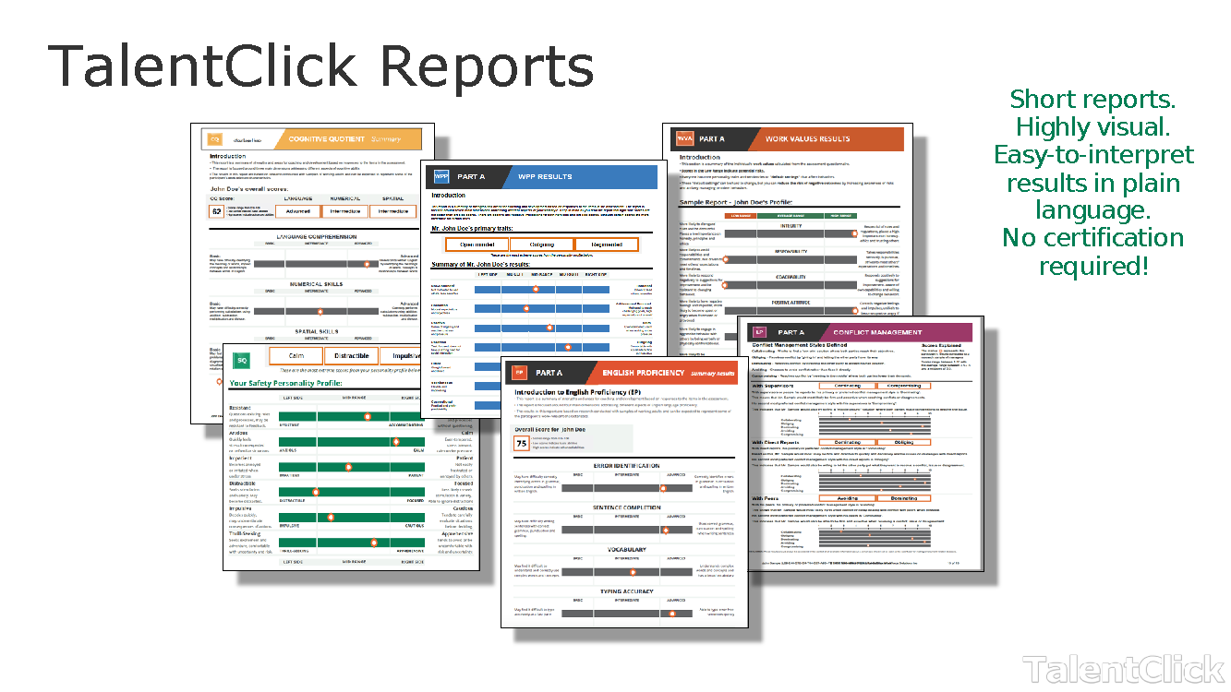

Benchmarking
The summary page of each assessment report displays “ideal scoring ranges” based on extensive benchmarking of high performers in each role. We have hundreds of roles in our Benchmark Library that you can use right away.

Fit Scores
Also on each report, we include an ideal fit score (or “cut score”) that serves as a YES/NO recommendation and lets recruiters see, at a glance, how close a match the applicant is to the ideal profile for each particular role. In this way, recruiters save time by more quickly sorting and prioritizing applications.

Note: We can include several types of ideal fit indicators, but most of our clients choose the visual format below which appears as a Green/Yellow/Red indicator. The box will be shaded with Green if the applicant scores over 75% fit. However, we can adjust that cut score up or down according to your needs. See examples below.
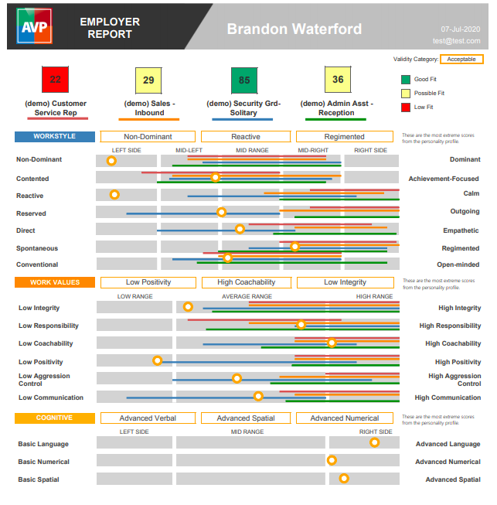 | 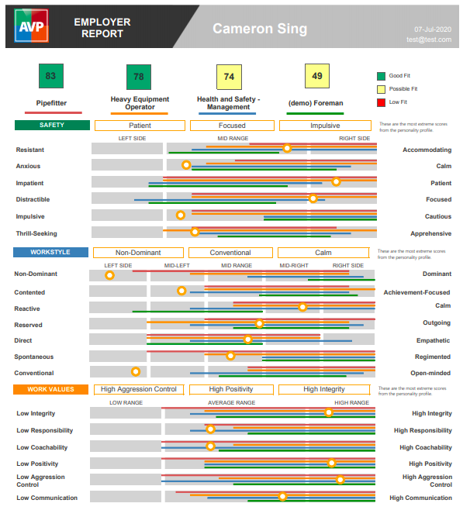
Reports also include two other components:
- summary of strengths and potential challenges related to fit
- suggested behavioral interview questions, which are personalized and tailored to each person’s individual results

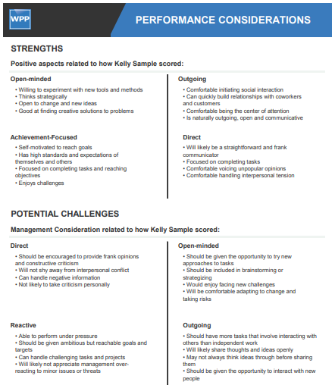 | 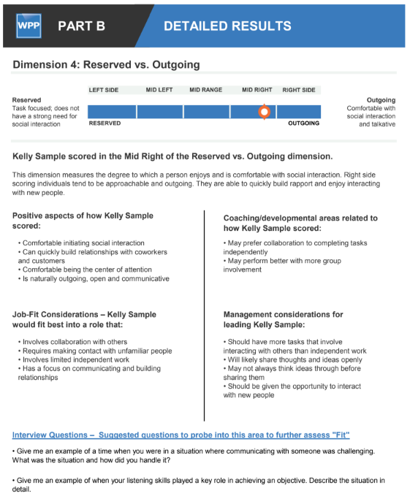

Using the Results
Our suite of assessments is used for (1) pre-hire screening, (2) pre-hire interviewing and reference checks, (3) post-hire training, development, and coaching, and (4) high-potential identification for succession planning. The tools can be used for people in all roles, from administrative up to senior leadership.
Our assessments are valuable at all stages of the employee life cycle, including recruitment and selection, employee development, and succession management:

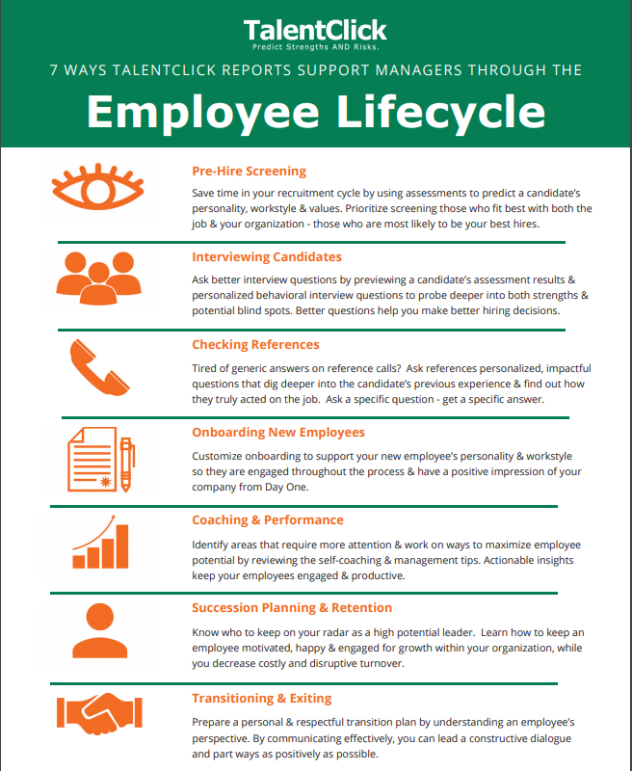

Application #1: Use the Results During Pre-Hire Screening

Are your recruiters overwhelmed with applications and don’t know who to start with? Do they spend too much time talking with candidates who simply are not right for the job?
Use the results to identify the best applicants. It’s simple!

Individual Fit Scores: Just select the benchmark for the job title/role against which you want to compare the candidates. (We have hundreds of roles in our Benchmark Library that you can use right away.)

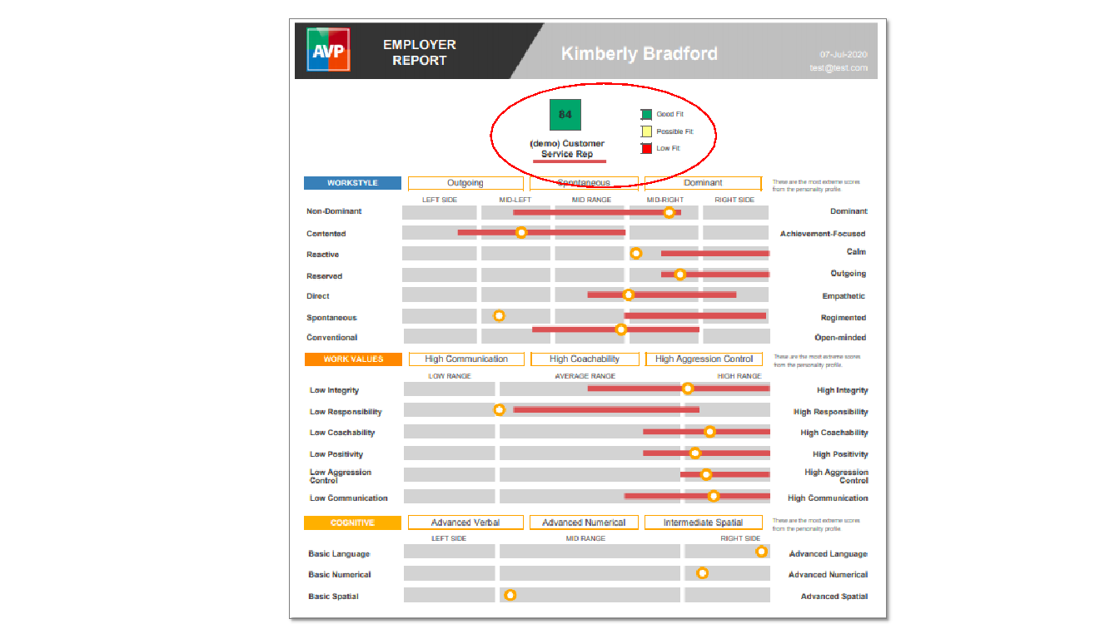

To make it extremely easy for your recruiters and hiring managers to prioritize job applicants, the reports will have a “fit score” along with Green/Yellow/Red shading. Green means Go, so a candidate with this type of score would usually get prioritized in Pile A, while someone with a Yellow score may be sorted into Pile B. Of course this all depends on how many roles you need to fill and how many applicants you get per open role.

Sorting Multiple People by Fit Score: Additionally, we make it easy to sort a large number of applicants at one time. On the home page of your portal account, just use the ‘Fit Score Sorter’ and it will rank all the applicants from highest/best score to lowest.

It’s important to remember that the Fit Scores are a non-partisan tool based on objective data and statistical probability. Because the analytics don’t care what a candidate looks like or sounds like, our assessment results help remove the subjectivity and bias that we can all be prone to. This greatly helps increase your likelihood of hiring a star performer.
Important: Please keep in mind that our tool is just one piece of the hiring puzzle. You still need to do interviews, reference checks, background checks, skills testing, and other methods.

Application #2: Use the Results for Interviews and Reference Checks

Regardless of which assessment report you use, we recommend that you use the personalized behavioral-interview questions within each report. This data-driven, objective methodology helps remove subjectivity and “interview bias” from the selection process, which helps you increase your likelihood of hiring top performers.

It can also help generate more authentic responses from the candidate when they see that you have special insight into their true personality and likely behaviors on the job.

Many employers also use the interview questions when conducting reference checks. It can help to solicit more helpful answers from the reference when they, too, know that you have insight into the candidate.

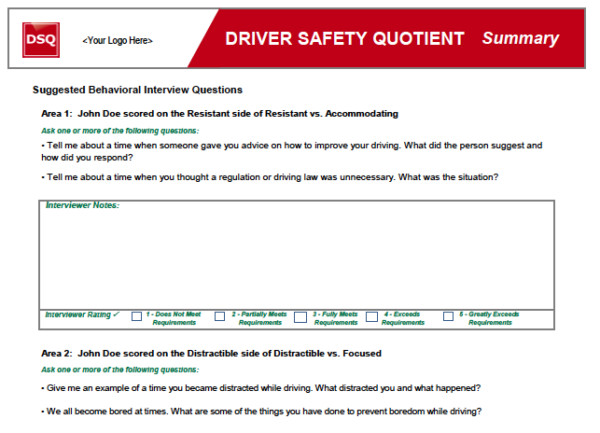

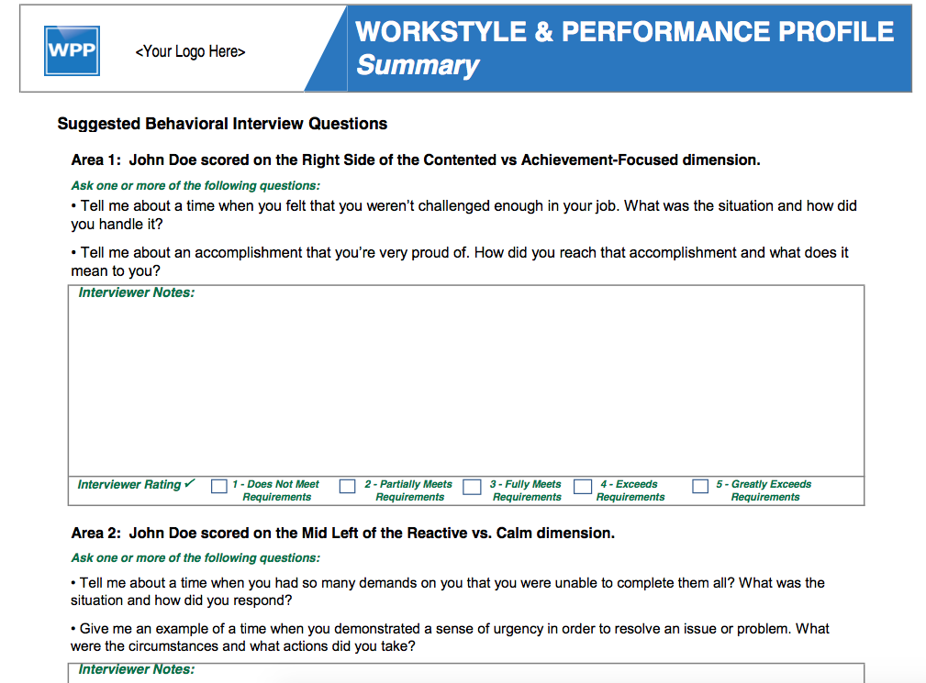

Application #3: Use the Results for Training, Development, Coaching

We also recommend that you use the reports as part of your employee L&D (Learning and Development) program.

Employer Report: The Employer Reports include strengths, potential challenges and management considerations to use when working with employees. Should you choose to hire the candidate, now you know what you’re getting! And we provide tips for supervisors to lead and coach the employee in order to help them succeed.

Participant Report: For each person who completes the assessment, along with the Employer report, our system automatically produces a Participant report (image on the right, below). These Participant reports (which are included with your subscription) should only be given to employees, not applicants. These reports are written with positive language that emphasizes strengths and areas for improvement. It is meant to empower employees with self-insight that can help one to monitor their own impulses and urges and to make better choices, This is proven to lead to safer behaviors and better outcomes!

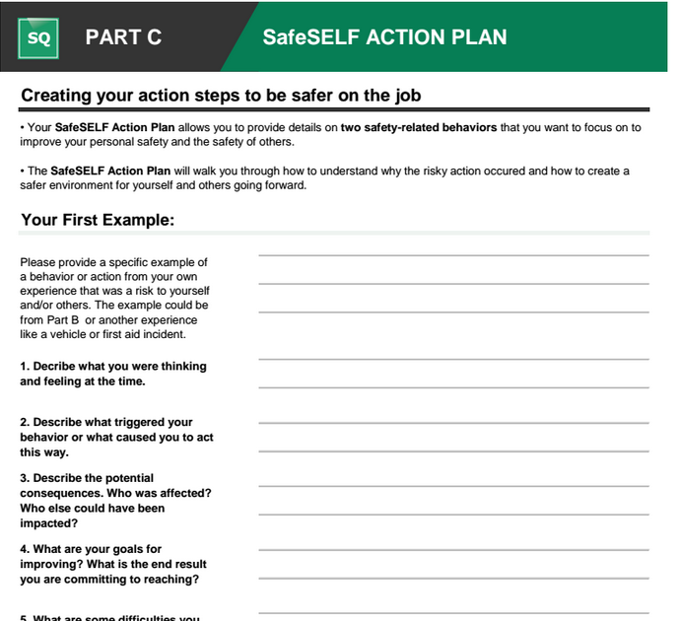
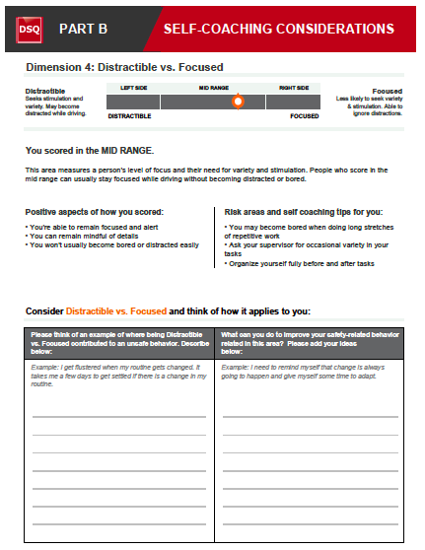
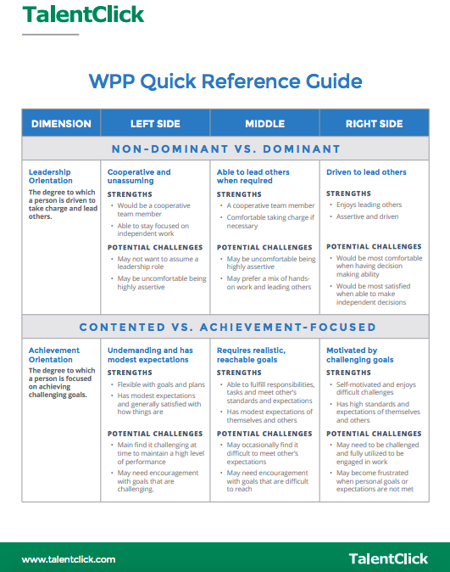

Leadership Coaching & Development
Along with employee training, many TalentClick clients use our Leadership Profile (LP) for the coaching and development of senior managers and executives. In our experience, when having coaching conversations with leaders, it helps to have a data driven tool from an objective, third-party provider. (Note: We also can provide 360 Degree Reviews, which nicely complement the assessment reports.)
The Leadership Report (LP) contains several sections:
- Workstyle & Performance Profile section: measures leadership dominance, self-drive and ambition, emotional intelligence, and more.
- Business Reasoning: measures numerical and verbal reasoning abilities, along with strategic thinking abilities.
- Conflict Management style: measures each person’s natural default mode of resolving conflict with three types of colleagues: (i) superiors, (ii) peers, (iii) subordinates.
LP results for each of the sections above provide ample insight for a leadership coach to address areas for improvement.
Along with the Employer report described above, we also provide a Participant report which can be given to the leader. The Participant report is written with positive language and provides self-insight and self-coaching opportunities.
The images below are screenshots of various pages in the Employer report. We have not included screenshots of the Participant report, but they are quite similar; the difference being that the language is written with ‘you’ and ‘your’ pronouns and speaks directly to the leader.
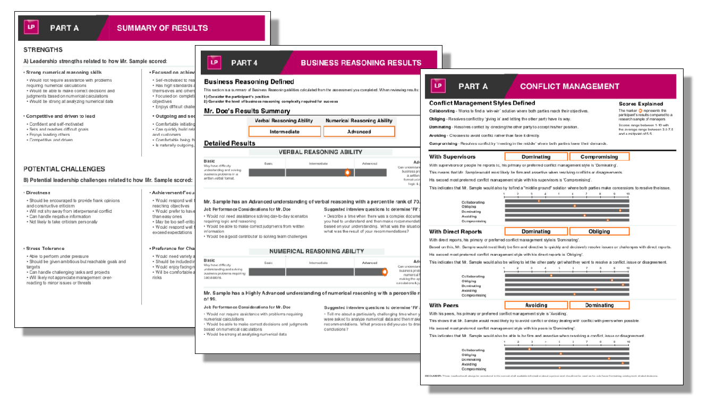

Application #4: Succession Planning
TalentClick clients often use assessment results to help with succession planning. Over the past 20 years, TalentClick’s chief psychologist, Stephen Race, has led “hi-po” (high potential) identification programs at a number of large organizations, including Telus, MTS (Manitoba Telecom Services) and Citizens’ Bank.
TalentClick clients use the Leadership Profile (LP) for identification of employees with high leadership potential as part of leadership development and succession planning programs. As part of a succession planning program, the LP provides the ‘Talent Inventory’ of the current and potential abilities of leaders and future leaders. The areas for development identified by the LP can be mapped to personal development plans of the leaders, which is in turn linked to the requirements for success in future positions. The result of this process is clarity of what steps need to be taken to address the gaps between current leadership capabilities and future desired capabilities.
The LP is unique in that it forecasts an employee's leadership style and abilities even if they have no prior leadership experience. In order to help remove ‘selection bias,’ the LP assessment does not rely on any of the following info about the employee:
- Age
- Gender
- Race/Ethnicity
- Work background or experience
Personality traits, problem solving skills and conflict resolution skills are all part of the LP assessment to provide the employer a preview of an employee's natural leadership style and capability to develop into an effective leader. The LP Employer version report includes suggested interview questions and hiring considerations for leadership candidates.
Click here for more LP details: https://www.talentclick.com/solutions/leadership-profile/

Helpful Resources
Most clients tell us that it’s super easy and intuitive to use the assessment results. But if you’re ever stuck, we have many helpful resources in our TalentClick Learning Academy. These resources include video tutorials, worksheets, quick-reference guides (“cheat sheets”), and more.
For a complete guide to Using TalentClick assessments, click here https://www.talentclick.com/wp-content/uploads/2020/12/General-Guide-to-Using-TalentClick-Assessments-AVP.pdf
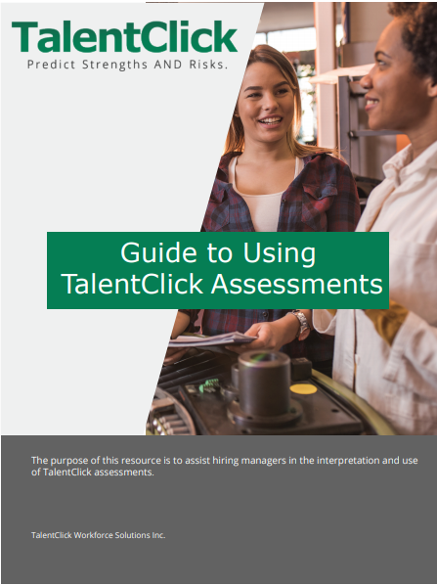

Answers to many common questions regarding our assessments can be found here: https://www.talentclick.com/faqs/
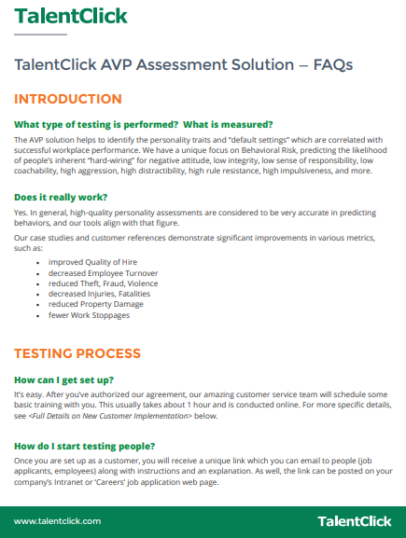

TalentClick Customer Stories
Customer Stories showing how our clients have used TalentClick for recruitment and selection are available at https://www.talentclick.com/resources/category/customer-stories/. See two examples below:
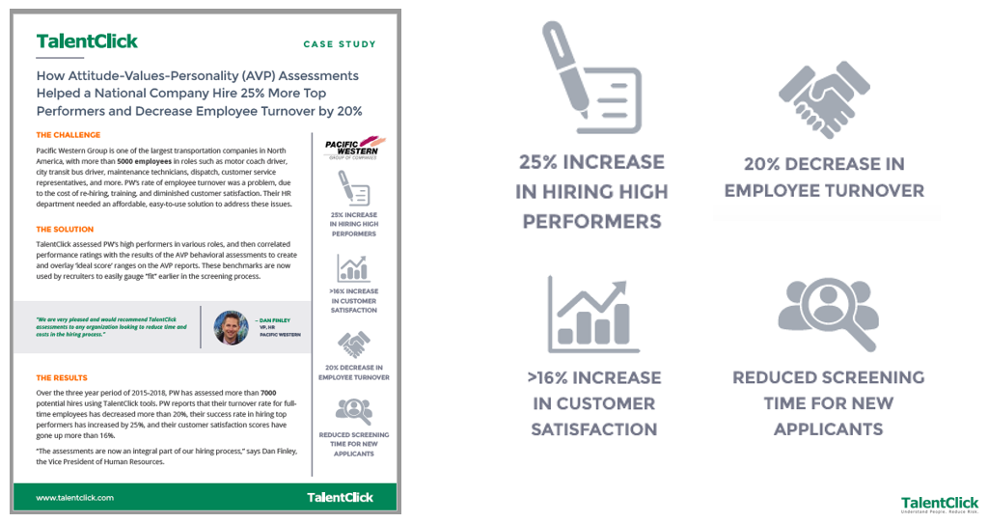
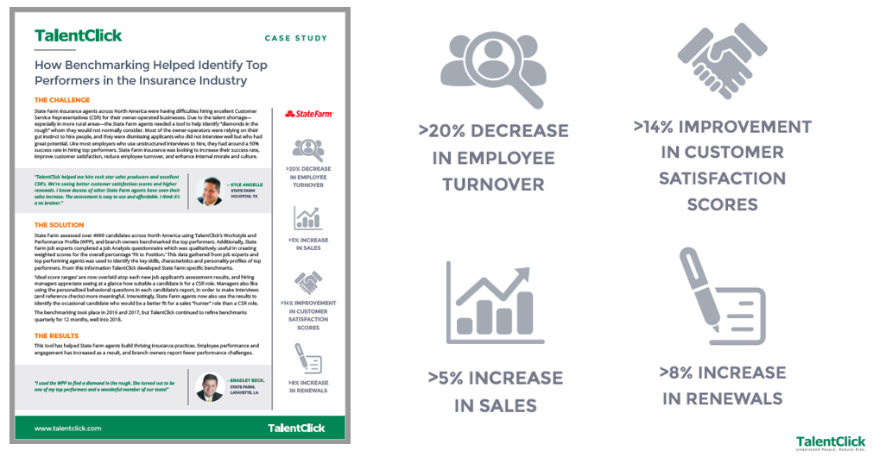

Part 5: Additional TalentClick Information

Summary
Headquartered in Vancouver, Canada, TalentClick was founded in 2012 by co-owners Greg Ford and Stephen Race when they decided to merge their collective expertise in order to disrupt the field of psychometrics, which was much in need of innovation.
Greg and Stephen made a deliberate decision to create simple, easy-to-interpret assessments offered through unlimited-use subscriptions at a price so affordable that employers could test as many people as they wanted. Today, TalentClick is a global leader, with thousands of business leaders using our employee assessments in over 100 countries worldwide to hire and train better employees and create happier, safer, and more productive workplaces. The result? Organizations are saving time, saving money, and making money!

Accolades
TalentClick has been mentioned in many news media around the world, including Bloomberg News, Huffington Post, Fox Business News, and Yahoo News.
We have frequently been recognized as a leader in our field, including:
- 2015 Deloitte "Companies to Watch"
- 2017 selected by the Government of Canada for the Canadian Technology Accelerator (CTA) program in Boston
- 2018 selected by Certified Professional Human Resources (CPHR) Association of British Columbia to be the exclusive training provider to its members for the Certified Talent Assessor designation.

TalentClick presents regularly on the topic of personality assessments for hiring and development at key conferences across North America, including these speaking engagements in recent years:
- Chartered Professionals in Human Resources BC (CPHR BC) Tech Symposium, Vancouver
- Association of Public-Safety Communications Officials (APCO) in Canada, Halifax
- Canadian Credit Union Human Resources conference
- Alberta Oil & Gas conference, Banff
- SSPC conference, Las Vegas
- American Society of Safety Engineers (ASSE) conference, Orlando
- IFMA, New Orleans
- PaperCon, Nashville
- NCSE, Jackson Hole, Wyoming
- CAM/ASSE, Detroit
- Tennessee Safety Conference
- Great Plains Safety Conference, Nebraska

Philosophy
When it comes to our assessment products, we believe in the school of positive psychology. This is displayed in the positive, respectful, encouraging language that we use in the reports. Every human being is born with “hard wired” personality default settings, and there is no ‘good’ or ‘bad’ personality. It’s all about fit to the job and fit to the culture. Some people naturally have the strengths to be successful in a role while others may be successful when afforded the opportunity to learn and grow. And THAT, in summary, is what we help work toward.

TalentClick Privacy
At TalentClick, our business revolves around people, and we have to exercise the utmost discretion when dealing with people and the confidential information we are privileged to collect. It’s a big responsibility. So, as you use our products and services, we want you to be clear how we’re using information and the ways in which we help protect your privacy. Our privacy statement is here: https://www.talentclick.com/privacy/, and we’ve tried to keep it as simple and transparent as possible, but if you have any questions or concerns please contact our privacy officer at privacy@talentclick.com.

TalentClick Security
TalentClick has comprehensive data security measures in place, including secure server storage and transmission, encryption of data, and backup systems. For more details, contact privacy@talentclick.com

Service-Level Guarantees

- System Up Time: We guarantee an ‘up time’ of 99% or higher. Occasional maintenance may occur, but you will receive advance notice.
- Report Delivery Time: We guarantee that after a participant has completed the survey questionnaire, the reports will be processed and available to you in your portal account within 1 hour on business days.
- Response Time: Technical issues emailed to support@talentclick.com will receive a response within 4 hours on a business day.

Validity & Reliability of Assessments
TalentClick assessments meet the standards specified in the EEOC’s Uniform Guidelines on Employee Selection Procedures (1978). We conduct ongoing research and data analysis to ensure that behavioral/personality assessments conform to all aspects of the Uniform Guidelines on Employee Selection Procedures (1978) including reliability, validity, bias and adverse impact based on gender, race, or ethnicity. The reliability of our assessments (measured by Cronbach’s Alpha) is typically in the .80 range and is not lower than .70. We conduct annual recalibration based on assessment and criterion data collected by customers. Benchmarks (target score ranges) are adjusted and criterion-related validity studies are performed regularly.
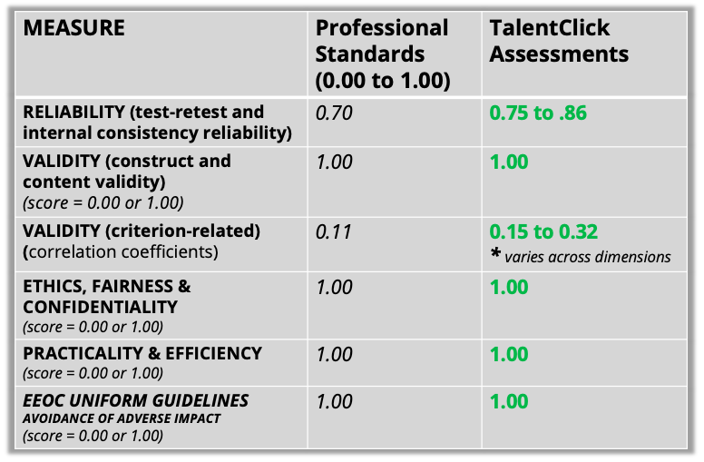

TalentClick’s Leadership Team

TalentClick’s team is led by individuals with significant expertise in the design, development and administration of assessments for hiring and employee development. Key personnel are listed below:
GREG FORD is the President & CEO of TalentClick, and he is heavily involved with developing TalentClick’s employee training and development solutions for clients. Mr. Ford holds a Bachelor’s degree in Psychology and a Masters degree in Adult Education & Workplace Learning. He has been a sessional instructor / adjunct professor at Simon Fraser University and NAIT. He has spoken at conferences across North America, has co-authored two books, and his articles have been published in Bloomberg, HR Reporter, People Talk, and Workplace Today.
STEPHEN RACE is the Chief Product Officer of TalentClick and head of product development and client services. Mr. Race holds a BA Psychology from the University of British Columbia and a Master of Science in Occupational Psychology from Birkbeck College, University of London, UK. He has led the development of TalentClick’s products and intellectual property since the company’s inception. Within the area of occupational psychology, Mr. Race has specialized in behavioral assessments and personality testing for 20+ years, and he is recognized as one of the top specialists in North America. He has acted as a subject matter expert on projects for the National Research Council of Canada. Clients have included: Accenture, SAP, Valero, SC Johnson, Telus, Best Buy, CN Rail, Lafarge, SNC Lavalin, Kiewit, Freeport McMoran, and more. He is a guest lecturer at British Columbia Institute of Technology and Simon Fraser University.
DR. SCOTT HAMILTON is widely recognized as one of the world’s foremost experts on psychometrics. Dr. Hamilton holds Master of Science and Ph.D. degrees in counseling and clinical psychology, with minors in research. For twenty years Dr. Hamilton held the positions of Chief Research Officer, Executive Vice President, and Chief Science Officer for Profiles International Inc. (acquired in 2014 by John Wiley & Sons Inc. for $51 million). He was instrumental in the creation, development, and implementation of Profiles International assessments, now found in more than 130 countries in 40 languages. He oversaw all aspects of assessment development while supervising the research and development team. Dr. Hamilton is a published author in the field and has directed research for both domestic and international audiences. He is a renowned public speaker, and has conducted effective business workshops in North America, Europe, South America, the Middle East, and Asia. While working as a professional in the assessment industry, Dr. Hamilton maintained memberships in the Association of Test Publishers (ATP), where he served on the Board of Directors, the Society for Industrial and Organizational Psychology (SIOP), the Association for Psychological Science (APS), the International Test Commission (ITC), and the British Psychological Society (BPS).
CHRIS KUNZE has 12 years’ experience building talent analytic models for assessment firms, including Wiley (Profiles International). Today, he uses Analytic Solver Data Mining algorithms to build people-related predictive models, Analytic Solver Simulation to forecast the ROI of personnel selection decisions, and Analytic Solver Optimization for NPV, budgeting and staffing problems. Estimating the value of personnel selection systems through the BCG utility formula is one of his specialties. Chris is multilingual having lived and worked in Germany, Italy and Spain. Chris’ work helps predicts employee performance, retention, satisfaction and safety.
RAND GOTTSCHALK is a Psychometrician with 30+ years of experience, during which he has specialized in the development, validation, and implementation of assessment tools in industry. He has been involved in the development, validation, and implementation of various types of tests including physical, cognitive, and non-cognitive as well as structured interviews and assessment center exercises. His work has encompassed various industries including automotive, software, metal, raw material, consumer products, and service. Some of his clients have included Ford Motor Company, Alcoa, Saturn Corporation, KB Homes, Pepsi Bottling Group, Chrysler, and the American Medical Association. Rand holds a Master of Arts in Industrial Psychology from Michigan State University.

SAMANTHA GOLDSTEIN, Program Manager, is a member of the team responsible for the development of TalentClick's proprietary products and delivery of professional services. She holds a Masters Degree in Organizational Psychology with a focus in Psychometric Development and Personnel Assessment. At TalentClick, Samantha supports the ongoing development of psychometric assessments, practitioner resources, customizations, training courses, group facilitation, and consultations to assist clients in the interpretation and use of employee results.

LIZ WHALLEY, Director of Business Operations, oversees the resources and systems that interconnect and client support administration, accounting, sales, and marketing. Working in operations roles for over 20 years, Liz ensures that TalentClick’s internal processes function effectively and efficiently to ensure the best possible experience for customers and partners.

JULIE ALLISON, Senior Client Implementation Manager, is TalentClick’s longest serving team member, having been with our firm for more than 10 years. Julie oversees implementation projects for new and existing clients, specializing in data analysis and customization of new reports. This includes leading project kickoff meetings, determining requirements, and conducting product training. As part of ongoing client support, Julie also manages feedback surveys, improves efficiencies, provides technical and product knowledge support, and works with our development teams to release new product features on an ongoing basis.

DEREK JOSEPH, Senior Client Implementation Manager, oversees implementation projects and support for new and existing clients, including leading project kickoff meetings, determining requirements, and conducting product training. Derek has over 20 years' experience managing large scale software implementation projects for clients in a variety of industries and locations, and he brings a wealth of experience to our Client Services Team.

From our team to yours, thank you for your interest in TalentClick.
We hope that we earn your trust and become a business partner for many years to come!

