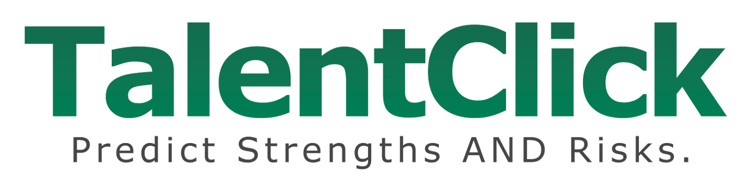

Proposal for

< Insert Customer Logo >

Prepared by:

< Name >
TalentClick Partner/Distributor
xxxxx@ABCxyz123com
ph: 1.555.555.5555

Insert Date

Introduction
Thank you for your interest in TalentClick Workforce Solutions. We are a world-class leader in the field of psychometrics, with employers using our behavioral assessments in over 100 countries globally and in 20+ languages. We are delighted about the opportunity to partner with you. This document outlines a proposed solution for your organization.

Our Understanding
<Insert Company Name, description of business, # customers, etc……
< insert name of CUSTOMER > is the second largest < insert info on CUSTOMER > in the USA, with XXXX employees in XX locations. With a focus on product quality and customer service, hiring and selection of top performing employees is essential.

Your corporate values are: Safety, Integrity, Respect, Reliability, Responsibility, Excellence

Of special focus to you are the # roles which make up XX% of your workforce: < insert info on CUSTOMER’s problematic roles with high turnover, high absenteeism, high safety incidents, etc. >.

OR if it’s safety related…
Our understanding is that your organization has made great strides in the areas of (a) safe equipment, (b) standard operating procedures, (c) training, and (d) hiring, and yet still the company is experiencing negative outcomes. You have told us that many of your incidents are due to human error and ‘human factors.’ Too often, employees are exhibiting a level of risk tolerance which is unsuitable for a hazardous workplace.

Objectives

<Company’s> leaders are searching for a talent assessment vendor that can assist with: (i) selecting top performers at the hiring stage, and (ii) helping with training and development for existing employees. Specifically, the desired outcomes are:
- improved ‘quality of hire’
- increased employee engagement
- decreased employee turnover
- reduced workplace incidents (injuries, theft, fraud, violence, harassment, etc.)

TalentClick’s solutions lend themselves well to your talent-management challenges and business objectives. We are pleased to present to you the following custom proposal.
Our Recommendation

Based on our understanding of your business needs and goals, we propose that you utilize TalentClick’s unlimited-use subscription which includes all of our tools:

TalentClick will provide not only Employer reports (for use during pre-employment screening and selection) but also Participant reports which may be given to existing employees to help them gain self-awareness and behavioral change (for use during employee training and development).

*NOTE: The advanced Leadership Profile (LP) is included in this proposal only as part of a Premium-level subscription.

Prior to Testing: We recommend that during our setup and implementation stage, we work together to map your job competencies to the most relevant personality traits, so that we can effectively measure them.
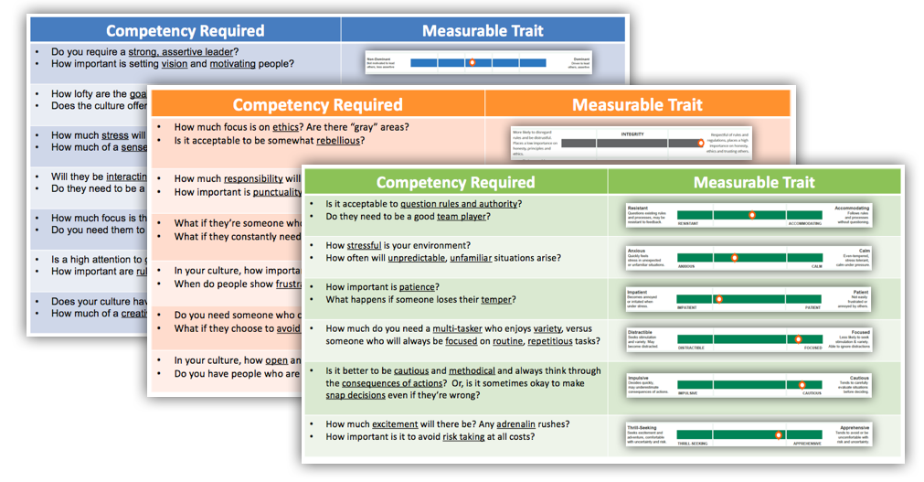

Testing Process: Our understanding is that you are seeking a streamlined process whereby you can invite candidates to complete the assessment questionnaire on-site or online prior to engaging with them. TalentClick can provide a 24/7 cloud-based, automated process:
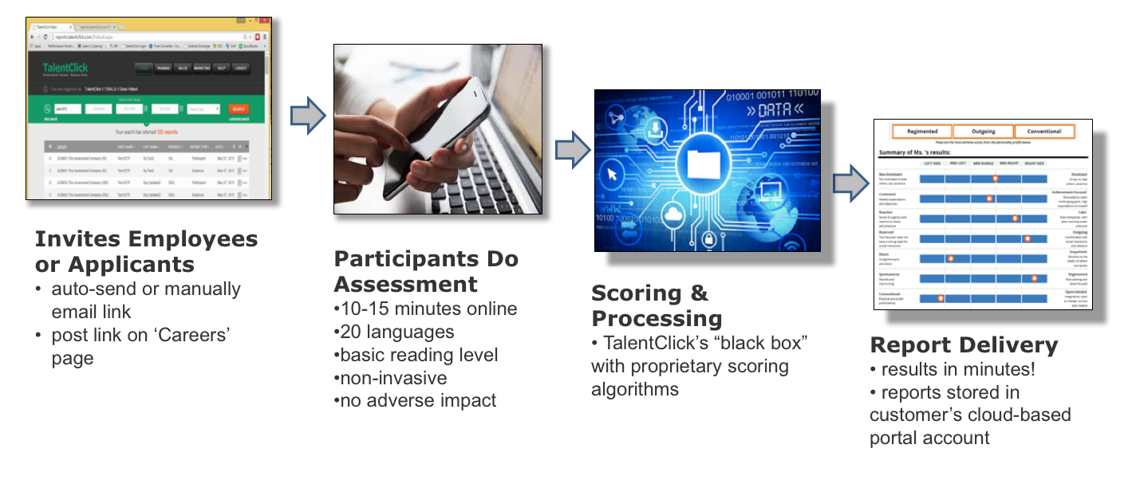

AVP Results
Our unlimited-use subscription includes our AVP (Attitude-Values-Personality) flagship assessment. To make it extremely easy for your recruiters and hiring managers to prioritize job applicants, we will add “ideal fit” scoring ranges based on our benchmarking of top-performers per job type. See image below as a sample:

We will automatically store results in your portal account in our cloud-based platform. If you wish, we will also email them as PDF attachments to your designated recipients. Finally, you may choose to use our API to complete an integration with your ATS/HRIS.

AVP Reports: From one 15 minute AVP survey questionnaire, we can configure your account settings to generate one combined report (as above) or multiple, separate reports (see below for more examples). You are free to use as many or as few of these reports as you wish and the price will not change.

Driver Safety Quotient (DSQ), Safety Quotient (SQ)  The SQ and DSQ and SQ are for organization’s concerned with safety to use either (i) during the hiring stage or (ii) for existing employees to teach ‘Safety Self-Awareness’ as part of a learning and development program. This report predicts the likelihood of someone acting impulsive, distractible, rule resistant, impatient, and more, and can be used to reduce safety incidents, road crashes, injuries, fatalities, property damage, and work stoppages / downtime. Employers use either the DSQ or the SQ report on an individual but generally not both.  *Employer and Participant versions both | 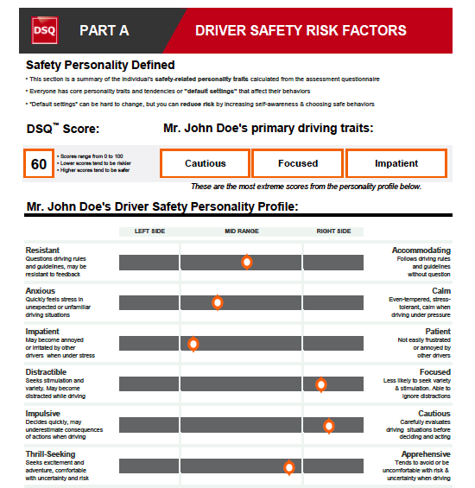
Workstyle & Performance Profile (WPP)  The WPP gives a preview of an individual’s natural “default” workstyle and provides accurate expeCUSTOMERtions for performance. The WPP reports contain action-oriented feedback on how to leverage the candidate’s natural workstyle and strengths. The reports also outline possible areas for coaching/development, job fit considerations, management tips, and suggested interview and reference-checking questions.  *Employer and Participant versions both | 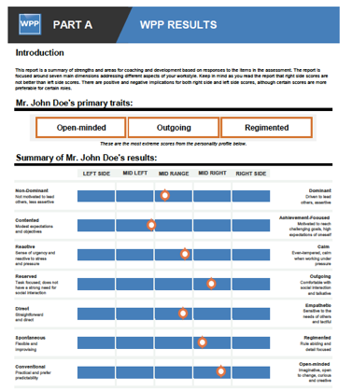
Work Values & Attitude (WVA)  The Work Values & Attitude (WVA) assessment is designed for employers to use at the screening, evaluation, and selection stage of the hiring process. When used as a part of a comprehensive selection process, the WVA will provide greater insight into an applicant’s integrity, sense of responsibility, coachability, positive or negative attitude, aggression control, and openness to communication.  *Employer version only | 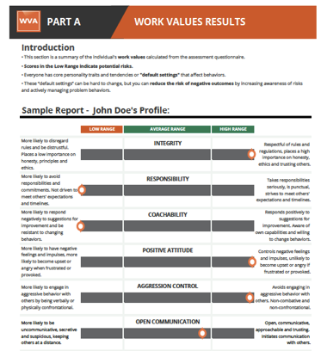

Additional Assessments
As part of a Premium-level annual subscription, we will also include our Cognitive Quotient (CQ), and English Proficiency (EP) assessments and Leadership Profile (LP).

Leadership Profile (LP)  45-60 min online assessment for senior managers and executives, measuring leadership tendencies, business reasoning abilities, and conflict resolution style.  Note: If you wish to use only one or two of the three sections, we can break out the desired sections separately. | 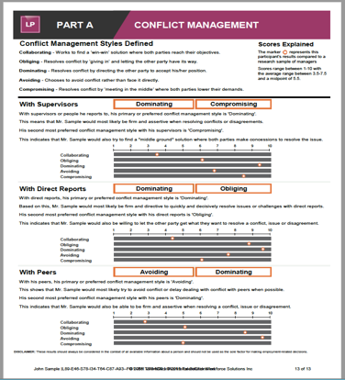
Cognitive Quotient (CQ)  25-30 minute assessment for junior and intermediate levels. CQ measures basic problem solving and spatial abilities, along with data entry skills and typing speed. | 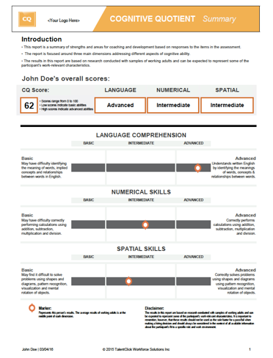
English Proficiency (EP)  20-25 minute assessment that measures ability to comprehend basic English language instructions, procedures, signage, etc. | 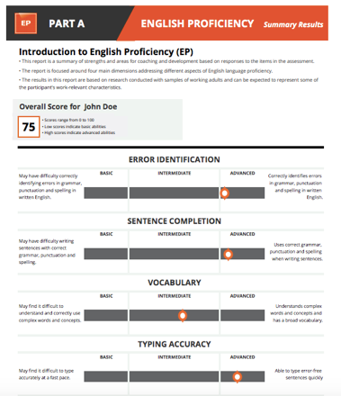

Use the Results for Interviewing

Regardless of which assessment report you use, we recommend that you use the personalized behavioral-interview questions within each report. This data-driven, objective methodology helps remove subjectivity and “interview bias” from the selection process, which helps you increase your likelihood of hiring top performers.

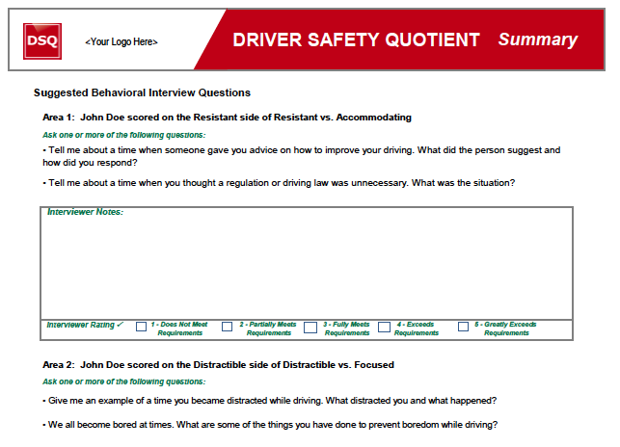

Use the Results for Training & Development

We also recommend that you use the reports as part of your employee L&D (Learning and Development) program.

Employer Report: Along with the summary scores in each report, there are also pages which outline performance considerations (image on the left, below). Should you choose to hire the candidate, now you know what you’re getting! And we provide tips for supervisors to lead and coach the employee in order to help them succeed.

Participant Report: For each person who completes the assessment, along with the Employer report, our system automatically produces a Participant report (image on the right, below). These Participant reports (which are included with your subscription) should only be given to employees, not applicants. These reports are written with positive language that emphasizes strengths and areas for improvement. It is meant to empower employees with self-insight that can help one to monitor their own impulses and urges and to make better choices, This is proven to lead to safer behaviors and better outcomes!

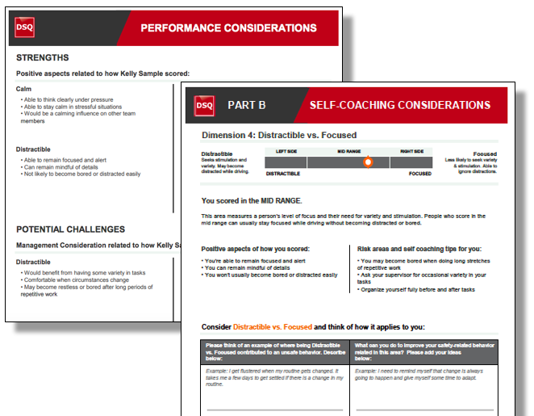
Technical Setup, Implementation, Training

Setup Process

Set up of your account can take place within 2 days to 2 weeks, depending on your schedules of availability. One of our amazing project managers will lead the process:

During the setup stage, we will work with you to configure the following:
- Which of the reports would you like to receive?
- Do you want separate reports or would you like them combined into one longer report?
- Who should have access to the results in your cloud-based portal account?
- Do you also want reports emailed to you as PDF attachments? If so, to whom do you want the results sent? (The reports can be sent to as many people as you wish.)
- Do you want Participants to automatically receive their own reports? We recommend No, unless you are sending it to employees only (not applicants) and you have already communicated the purpose of the tool and how to use it.
- Would you like your logo on the survey landing page and/or on the reports?

Product Knowledge Training

TalentClick’s product and implementation team will train and provide support to designated administrators within your organization. Training is comprised of recommendations on how to use and interpret the solution as well as tailor the solution to specific environments.

Portal Access

Included: We will provide a training session for your administrators on accessing the online portal, retrieving reports, filtering candidates by location, date, department, etc., and generating custom group reports to uncover trends and gaps in different areas.

Report Configuration

Upon your request, TalentClick can co-brand—with your logo and color scheme—the on-line assessment invitation, landing page, survey, and assessment reports.

Ideal Candidate Benchmarking

TalentClick will assist you in creating “ideal fit” scores for future hiring. This is done by benchmarking your top performers and then mapping their aggregate scores to view the common patterns.

System Integration

TalentClick assessments can be sent, received and viewed through your own HR Applicant Tracking System (ATS) if desired. At no charge, we provide an API that your technical team can use to complete an integration with your own system. If you wish us to be more heavily involved, integration costs would apply.

Delivery & Response Time Guarantees

- System Up Time: We guarantee an ‘up time’ of 99% or higher. Occasional maintenance may occur, but you will receive advance notice.
- Report Delivery Time: We guarantee that after a participant has completed the survey questionnaire, the reports will be processed and available to you in your portal account within 1 hour on business days.
- Response Time: Technical issues emailed to support@talentclick.com will receive a response within 4 hours on a business day.

Additional Notes for PILOT PROJECT

Based on our planning meetings with you, we have agreed that your organization will participate in a 30-60 day pilot project. We will provide this at no cost, unless you request specialized or customized “out of scope” solutions for the pilot project.

- TalentClick agrees to offer 30-60 day pilot project. Link will expire after XX days.
- test XX to XXX people in the following roles or locations < insert info on CUSTOMER roles they wish to test. Most trials are for 1 or 2 benchmarked roles. But as a trusted partner/distributor, you are empowered to enlarge it beyond 1-2 roles and/or to extend it to 90 days for a large employer with high potential. Note: If you are NOT offering a pilot project and are simply moving ahead with the paid subscription, then delete this paragraph. And congratulations! >

Pricing

TalentClick will provide the following solution and pricing, based on our discovery meetings prior to this agreement.

- Scope: Annual subscription for (a) all positions within your organization OR (b) approximately xxxx people in XYZ department or location.
- Usage: Unlimited use. You may assess as many existing employees and/or applicants as you like for the scope described above, and our fee will not increase throughout the contract term.
- Solution: Standard OR Premium level package that includes the following products:
  - AVP package (Attitude-Values-Personality)
    - Workstyle & Performance Profile (WPP) assessment
    - Work Values & Attitude (WVA) assessment
    - Safety Quotient (SQ) assessment
    - Driver Safety Quotient (DSQ) assessment
  - Leadership Profile (LP) assessment
  - Cognitive Quotient (CQ) test
  - English Proficiency (EP) test
- Links: X dedicated links (Note to partner: 2 links for each $5k of sales revenue)
- Custom Benchmarking: criterion-related validation/analysis for X roles (Note to partner: 1 custom benchmark for each $10k of sales revenue)
- Training: X remote web sessions for product knowledge training and portal training. Additional sessions may be purchased. (Note to partner: training session for each $10k of sales revenue)
- Start Date: Contract will automatically begin on <DATE> upon successful completion of the pilot project. If you are not 100% satisfied, just provide email notification that you will not be proceeding with a paid subscription.
- Guarantee: Anytime within the first 12 months of the contract, if you are not 100% satisfied, you may provide 30 days’ written notice and TalentClick will refund a pro-rated amount for the unused months remaining in the initial annual term.

COST: USD$XX,XXX.00 per year

- All prices are in U.S. dollars.
- Payment must be made up front and is due within 30 days of invoice date.
- Subscriptions automatically renew unless Customer provides 30 days’ written notice.

Additional Fees:
- We charge additional fees of $250 per hour when a client requests out of scope professional services beyond what is quoted in the Customer Agreement. These services include job analysis, benchmarking, report interpretation, assessment customization, additional training.
- Expenses for travel (pre-approved, when requested by client) are additional.

Thank you for the opportunity to earn your business as a trusted partner helping you achieve your goals. We look forward to working with you!

TalentClick
TalentClick Workforce Solutions Inc., Suite 1200, 555 West Hastings St., Vancouver, Canada, V6B 4N6 1.877.723.3778

CUSTOMER AGREEMENT: Annual Subscription
Employer/Company Name: | Employer Contact Name and Title:
Employer/Company Name: | TC Partner/Distributor? |  | TC Account Manager
Date:
Products/Services Included |  |  | Project Manager | Costs/Fees
Premium level annual subscription for approximately _______ employees.  Unlimited use starting ________ and continuing until cancelled. Includes:  - AVP solution: Workstyle & Performance Profile (WPP), Work Values & Attitude (WVA), Safety Quotient (SQ) and/or Driver Safety Quotient (DSQ)  - English Proficiency (EP), Cognitive Quotient (CQ), Leadership Profile (LP)  - Includes both Employer and Participant reports (for hiring and training)  1 user training session for TalentClick’s cloud-based portal account with Benchmark Library and Team Analytics.  2 dedicated links for different tests, locations, managers, etc.  1 custom benchmark(s) using Customer data on top performers in a role |  |  | Derek Joseph  Guidelines for TC Sales:  (1 Training per every $10K)  (2 Links per $5K)  (1 Benchmark per $10K) | $________  per year
Optional Products/Services (not currently included):
- $150-250/hr for additional services requested (eg. extra links, training, benchmarking, results interpretation, report customization, data analysis)
- Any expenses related to travel requested and pre-approved by Customer
Total: Pricing is in U.S. dollars. Any applicable taxes are extra.  Terms: Due upon receipt. 2% interest added each month on overdue payments. |  |  |  | $______.00  USD
Please Complete Billing Instructions
Billing Contact’s Name:
Mailing Address:
Email Address of Billing Contact:
Phone:
Other instructions (eg. PO# or Credit Card #):
Within the first 12 months of the first term, this contract may be cancelled at any time with 30 days’ written notice, and TalentClick will refund a prorated amount equal to the unused months remaining in the initial annual term. Thereafter, this contract shall automatically renew annually under the same terms until either party provides 30 days’ written notice. Customer grants TalentClick the non-exclusive worldwide right to copy, store, record, transmit, maintain, display, view, print, or otherwise use Customer data only to the extent necessary to provide the offerings to Customer and conduct general research in the field of study. TalentClick warrants during the Term of this Agreement that we will use commercially reasonable efforts to ensure that Customer’s data will be safeguarded and maintained accurately in a manner consistent with our own internal confidential information. CUSTOMER ASSUMES ALL RESPONSIBILITY FOR DETERMINING WHETHER THE SERVICE OR THE INFORMATION GENERATED THEREBY IS ACCURATE OR SUFFICIENT FOR CUSTOMER’S PURPOSES. Customer shall indemnify and hold TalentClick harmless from and against all claims, suits, demands, actions and proceedings, judgements, penalties, damages, costs and expenses (including legal fees and costs), losses or liabilities of any kind which may arise or result from the use of TalentClick products or services. TalentClick shall retain ownership of all technology and intellectual property associated with the product. The acceptance of this Agreement shall form a contract under the laws of the Province of British Columbia.
______________________________________________________________________________
Customer Signature Date

